Dynamics of air transport networks: A review from a complex systems perspective -- Luis E.C. Rocha

https://www.sciencedirect.com/science/article/pii/S1000936117300171

‘At the mesoscopic level, one may define the network community structure to identify groups of nodes more connected between themselves than with nodes at other groups. A typical example is the community structure formed by a country in which several connections occur between airports within the country but few connections link a couple of international airports with their counterparts at another country.’
This part shows how airports connectivity can not only shown by the connecting airports it has but also examine what kind of routes it has. For example even thought Atlanta Hartsfield International (ATL) is the airport that handles the most passengers in the past few years it is not the main international hub for the United States since it mainly deals with domestic flights and only has limited amount of international flights operated by Delta and other SkyTeam members.

‘Numbers represent the times in which the links are active or available. Airport P looses importance if considering the temporal paths. Because some flights occur before others and the network becomes not strongly connected (i.e. not all nodes can be reached by any other node in the network). Note that in this simple example, the centrality of a node may completely change in a way not captured by using the standard static network formalism over a sequence of different network snapshots.’
This part shows another aspect of the connectivity of airports. If the airports have route networks that do not connect with the right timing it may increase the layover time for a transferring passenger thus lowering the connectivity of that airport.

‘One complication of modeling airports or flights as time-evolving networks is that a flight departs from airport P say at time t and arrives at another airport Q at time t + τ, where τ is the flight time. In principle, at times closer to t, the out-link at P is not “felt” by airport Q whereas at times closer to t + τ, the in-link at Q is not “felt” by airport P. This is particularly relevant for long-haul flights in which a delay on departure, for example, can be compensated inflight by increasing the aircraft speed and hence keeping τ fixed. In other words, because of the duration τ of the flight, the activation of the link is not synchronized in both airports, a phenomenon generally not observed in other systems modeled by temporal networks.’
This part shows that the delay is not necessarily going to spread across hubs, due to the change of airspeed, the difference between the scheduled time and actual flight time, a delay at the departing airport might not result a delay at the arrival airport and the next flight would not be affected, the passengers can get on their connection flights as planned. However this is just one scenario, on the broader page where a flight has a tight schedule, delay might still move along networks.

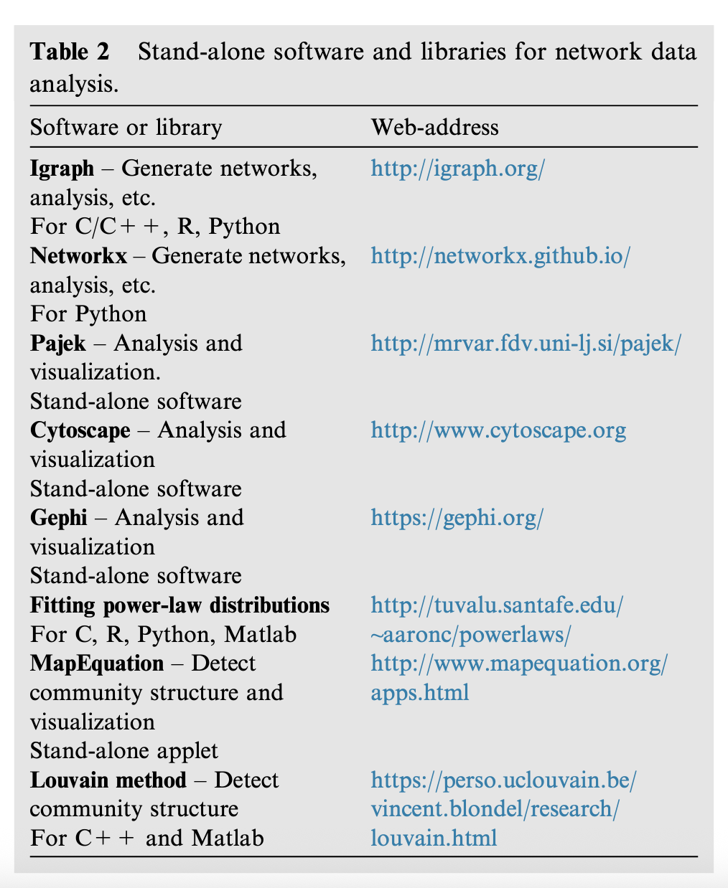

‘All studied networks in the literature showed a right-skewed distribution of degree, meaning that a few airports (i.e. hubs) have several routes and flights whereas the majority of airports have only a few routes and flights.’
This is a showcase of the hub-orientated network systems is the major trend in modern aviation.

‘They have observed significant variation in the degree and weighted degree at different months and in the weighted closeness (closeness measures the reciprocal of the average distance between a given node and all other nodes in the network) during the week. Furthermore, they have observed that airports are more clustered and have shorter distances between them during the week in comparison to weekends. They emphasize that the distribution of these centrality measures are heterogeneous and some airports are much more central than the majority.’
Also mentioned in other articles, the significant difference of route data between weekdays and weekends showed that the reason of traveling of passengers plays an important role in the scheduling of routes.

‘As expected, the average degree suffers a cyclic pattern in which summer months contain more routes than winter months.’
This part also shows that seasonal factor has influence on route planning since seasons control the traveling plan for most passengers, while the natural factors such as wind on airline route can also vary in different seasons.

‘Such analysis is relevant in the situation that the airspace of certain countries has to be reduced or closed temporarily as it happened in northern Europe during the eruption of Eyjafjallajökull Vulcan in 2010, in Belgium during the terrorist attacks in 2016 or during country-wide strikes of air traffic controllers or pilots. The increasing dependence of a few key countries and routes makes the air transport network more vulnerable to disruption because of unexpected localized events.’
This can connect to the regional conflicts that appears more frequently in recent years. For example, the conflicts in the middle east forces connecting hubs like Dubi, Doha and Abud Abbi fall into long ground stops for weeks, causing inconvenience in global travel and rising ticket prices on alternate routes.

‘In the context of the USA, Fleurquin and collaborators observed that in 2010, delays showed similar statistics for different days of the week and different seasons. Major differences however were observed for different airports. In all cases, broad distributions of delays were observed. For long delays (more than 12 h), they observed a relative concentration of delays early in the morning and late in the afternoon, in contrast to short delays (less than 12 h) that showed a nearly flat delay distribution during business hours. One limitation of this study was to consider only delays larger or smaller 12 h that is a too long interval. It would be interesting to estimate the statistics of shorter intervals of delays as for example, 1, 2 and 4 h.’
This part shows an interesting statistic, while pointing out great research to do in the future. The long delay happens in the morning and afternoons may because that these are the times where long international flights take offs and that they usually face long delays since they are easier to face problems like over-due crews, mechanical problems that can’t be fixed due to the plane’s home base is at another country.

